Prompt for leadership dashboards

What: create specific python scripts to reproduce the following list of visuals. Each category should be a separate script.

Why: i need to have a consistent output to share with leadership on a monthly basis.

Note: make sure to use the brand colors and style. Output in html, pptx or pdf.
The output images should be adjusting to the size of the page/slide, they should be responsive when possible. Incl tooltip when possible. Incl option to download raw data esp for table format visuals. Incl source tables, include recommendations, but be factual. We aren’t experts they are, we can only say what the data shows.

List of requirements with example visuals to use:

1. Global Snapshot:
KPI tiles:
a. Total ARR (in requested period), in Dollars, change to prior month/quarter and year, delta of change
b. Total Active Accounts (in requested period), change to prior month/quarter and year, delta of change
c. Total Churn (in requested period), in Dollars, change to prior month/quarter and year, delta of change, target value, above/below target
d. Renewal Rate (in requested period), in Dollars, change to prior month/quarter and year, delta of change, how it compares to averge
e. EO -Renewal Rate (in requested period), in Dollars, change to prior month/quarter and year, delta of change
f. EC -Renewal Rate (in requested period), in Dollars, change to prior month/quarter and year, delta of change
e. Opal -ARR growth, Renewals, accounts
Examples:
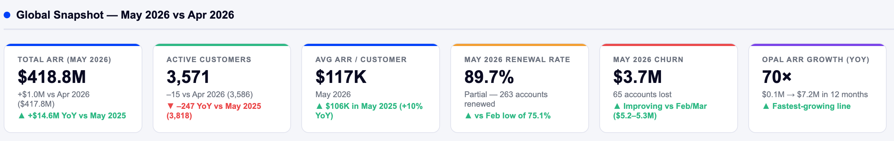
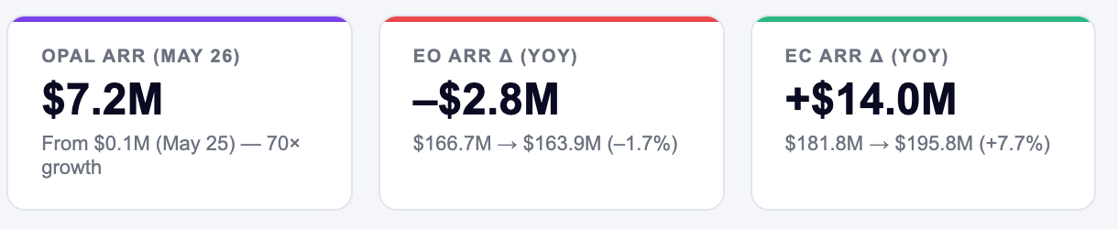
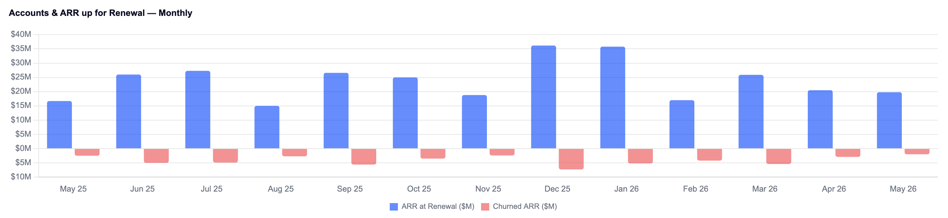

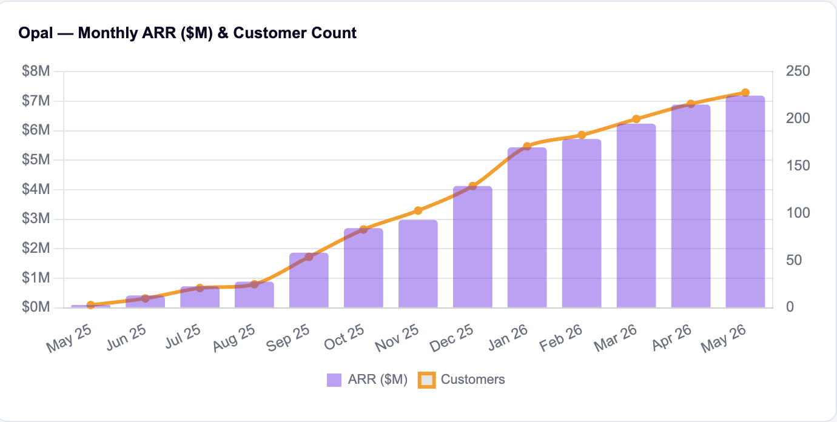
Trend line over time
f. Trend line over time (month or quarter) of Total ARR, Total Renewal Rate w average line comparison

2.Break downs: Output style= totals for requested period, monthly or quarterly trend line, bar-chart by dimension with tooltip key data displayed
a. ARR, Churn, Renewal Rate by Region = NAm, EMEA, APJ
b. ARR, Churn, Renewal Rate by Segment = Mid-, Enterprise, Other/Digital
c. ARR, Churn, Renewal Rate by single-/multi-solution
d. ARR, Churn, Renewal Rate by Product Solution = EO, EC, AI, Other
e. ARR, Churn, Renewal Rate by ARR band

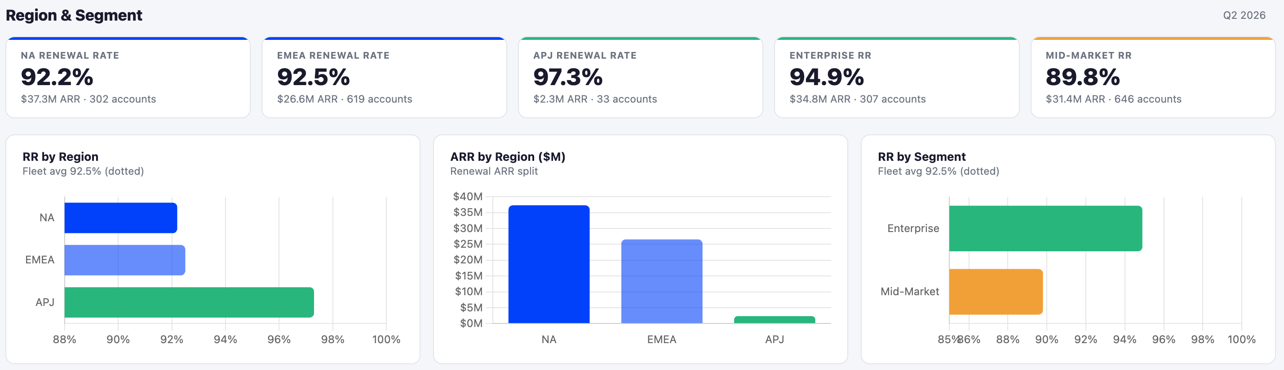
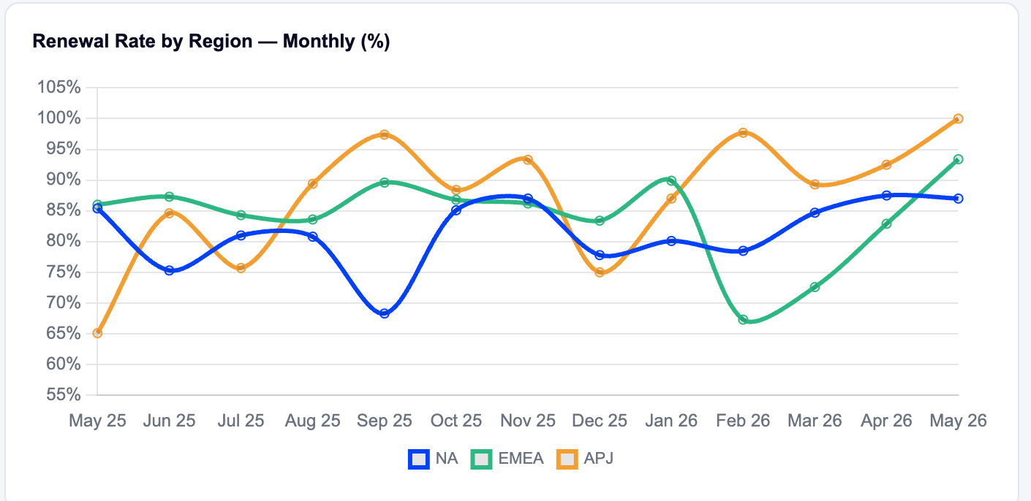

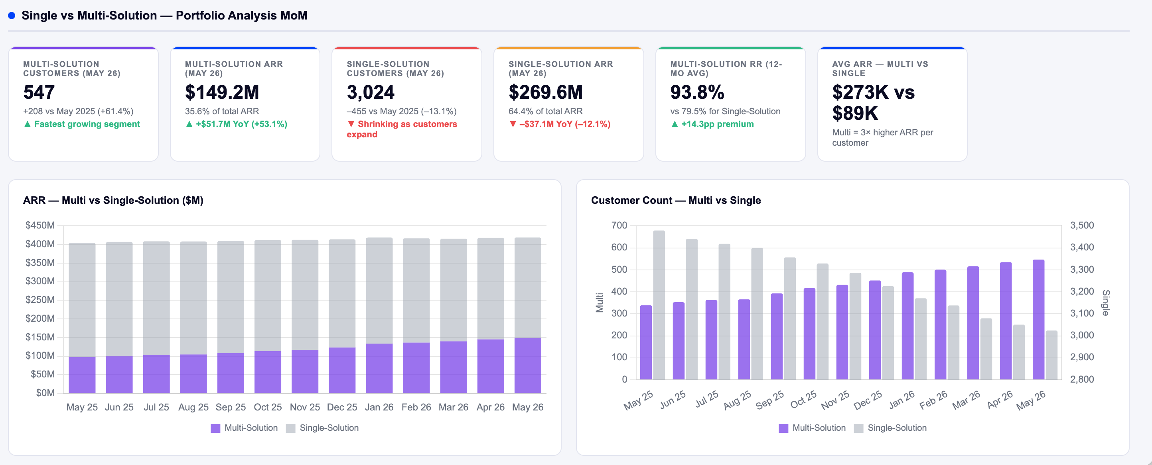
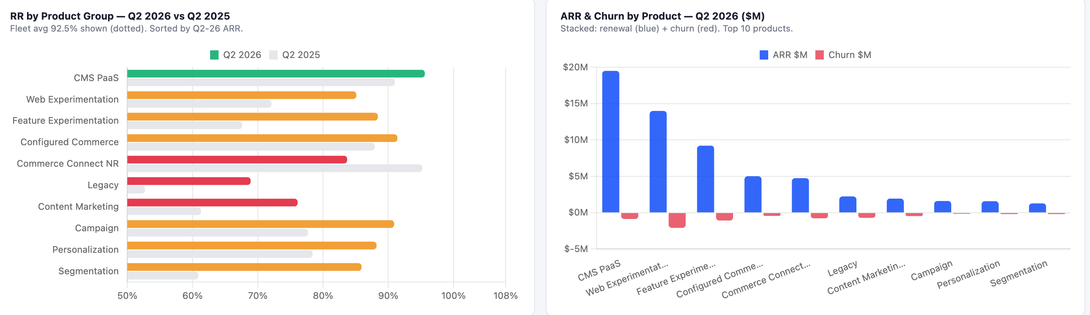
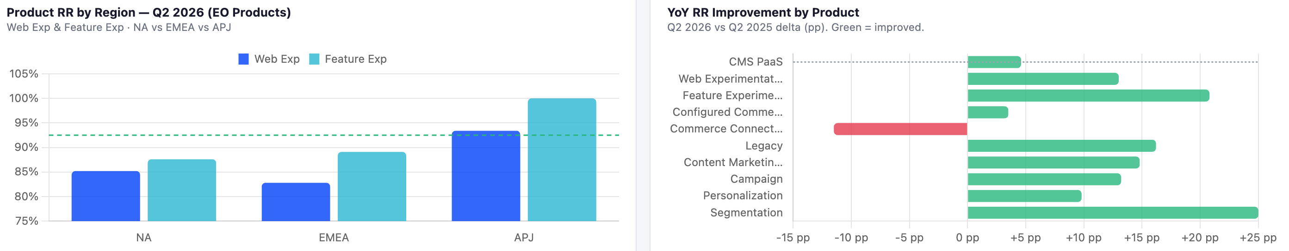

3.Deep Analyses
a.
i.Churn Codes: for 2026,
- use new churn codes to show accounts and ARR lost by churn code by quarter, by product solution overall, by competitor, by multi-/single solution, by product group.
- by goodfit bad fit, bycustomer age at churn
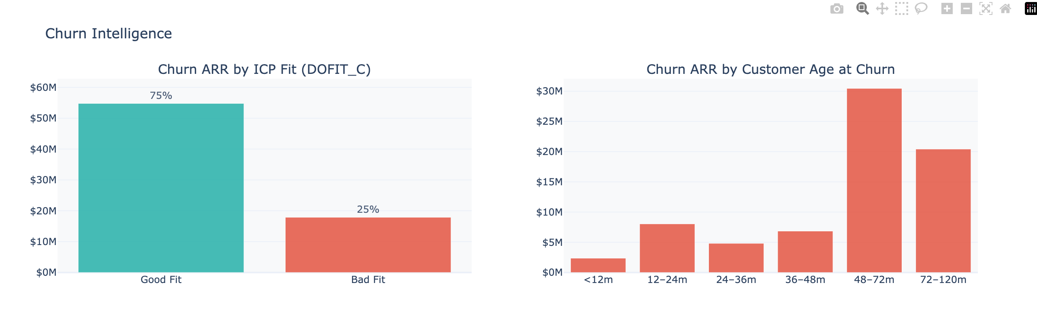
- Comparisons of top competitors by product solution.
- Use web-search for top 10 lost accounts to confirm loss reason.
ii. for Andie
- Analysis of Primary Churn Reason by % - across product solution
- Analysis of Churn Category by % - across product solution
- Analysis of Primary Competitor - across product solution
- Most important - AI analysis on both the "Reason Lost Detail" and "Renewal Notes" Noting the key themes across all our products.
- report by CS leaders/territory/sub-territory

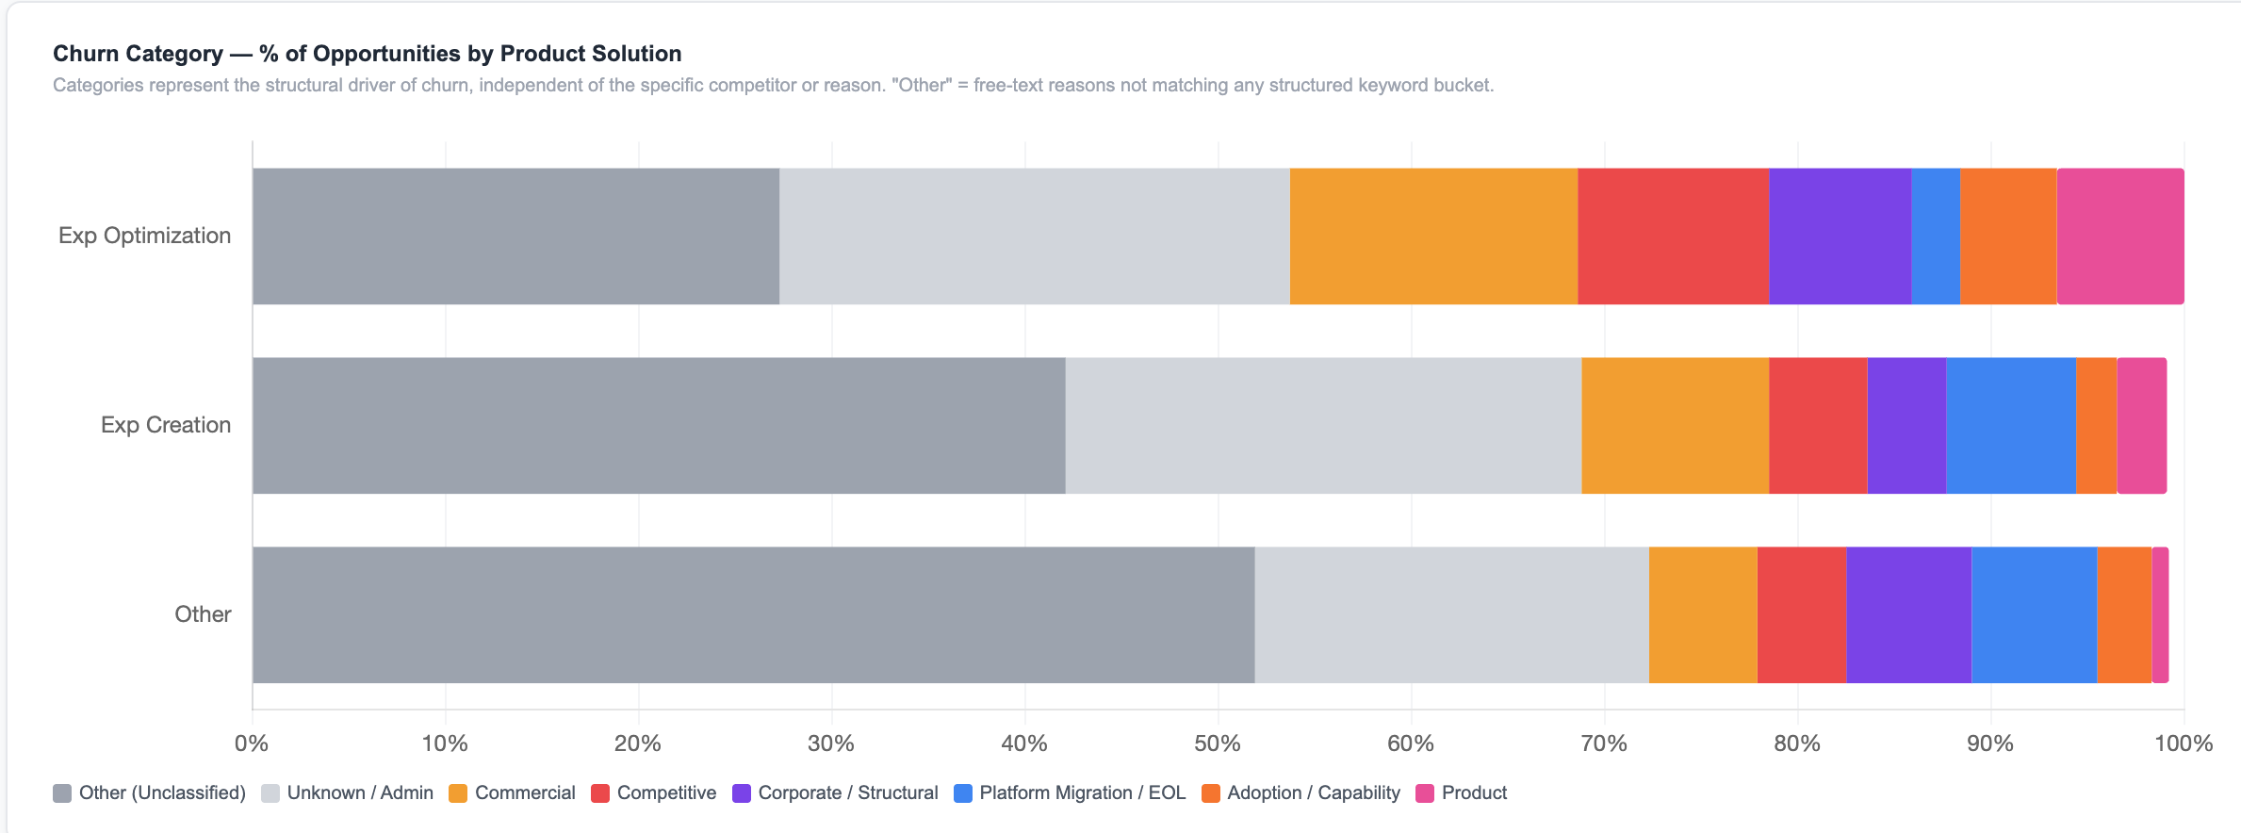

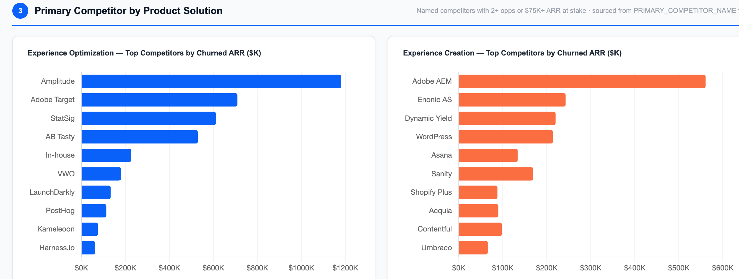
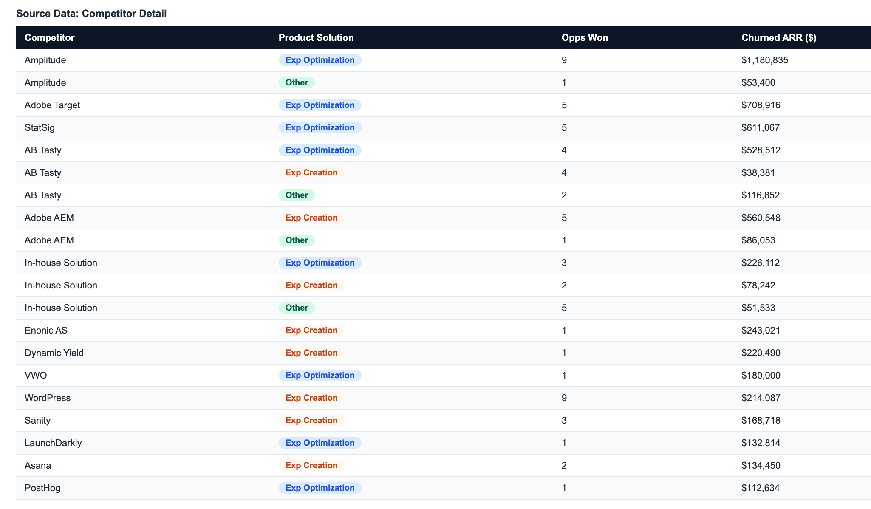
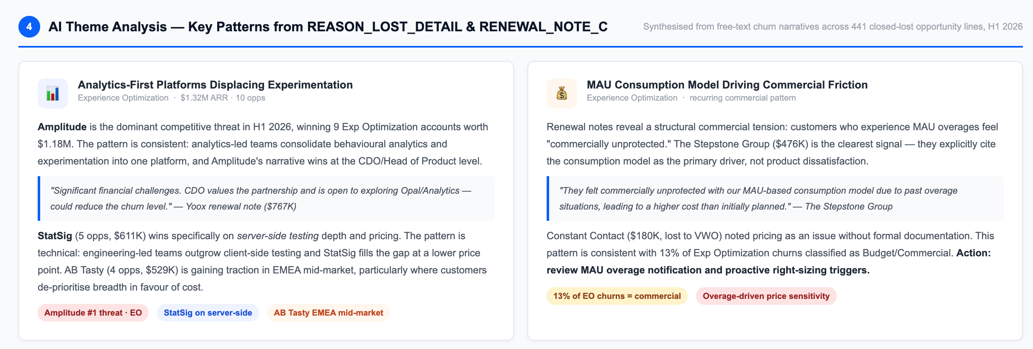

b. WebEx/FX Nam/EMEA deep dive: (excl APJ)
i. totals by product and by Region ARR, Churn, RR
ii. bar charts by region for ARR/Churn/RR by time period
iii. bar charts by product+region for ARR/Churn/RR by time period
iv. Opal attach correlation ARR/RR in time periods
v. High tester/low tester ARR/RR in time period
vi. next product from WebEx
vii. next product from FX
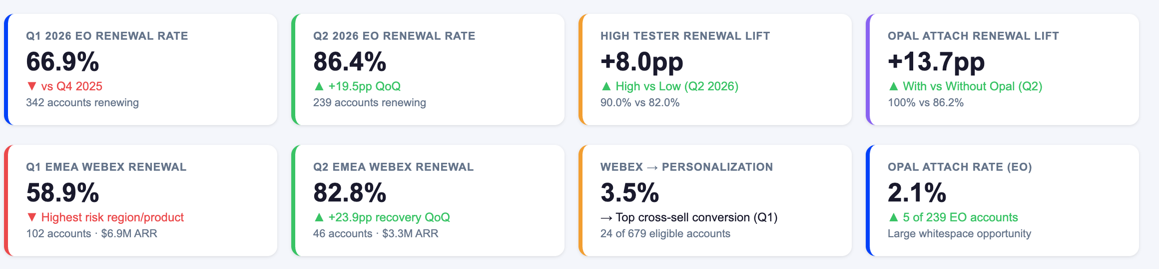
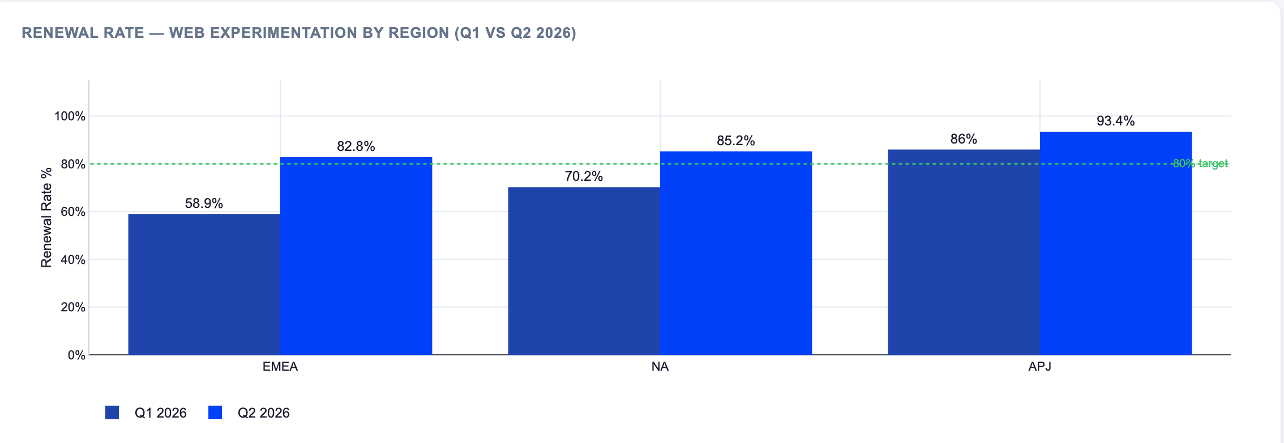
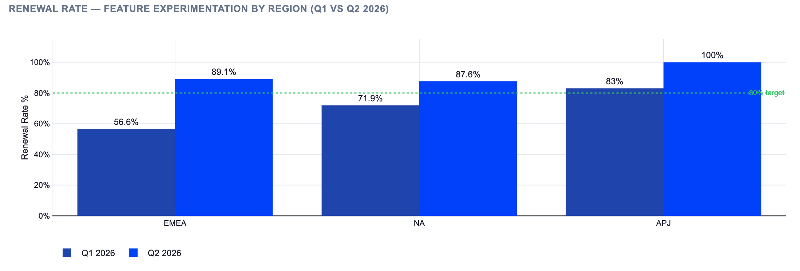
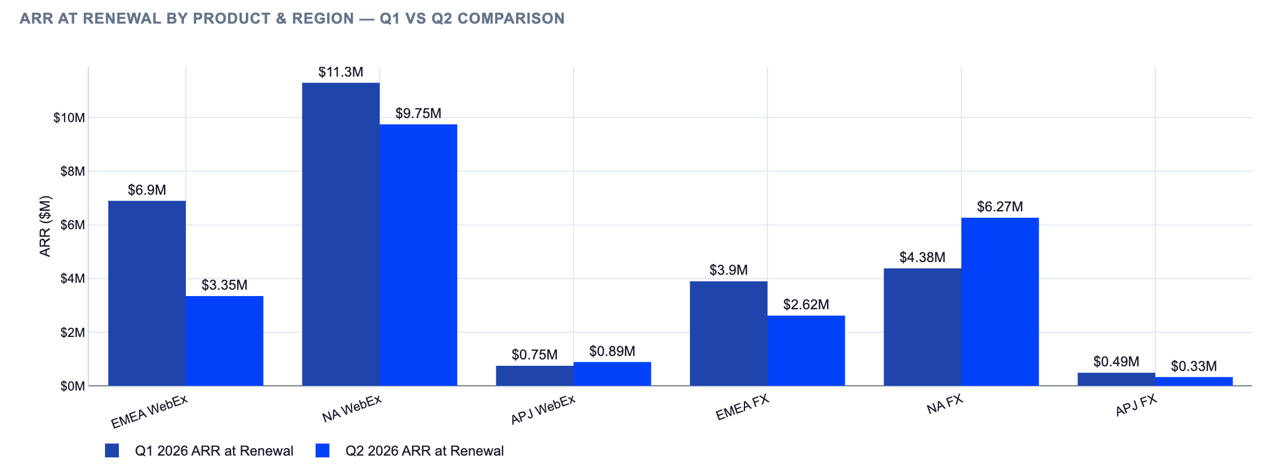
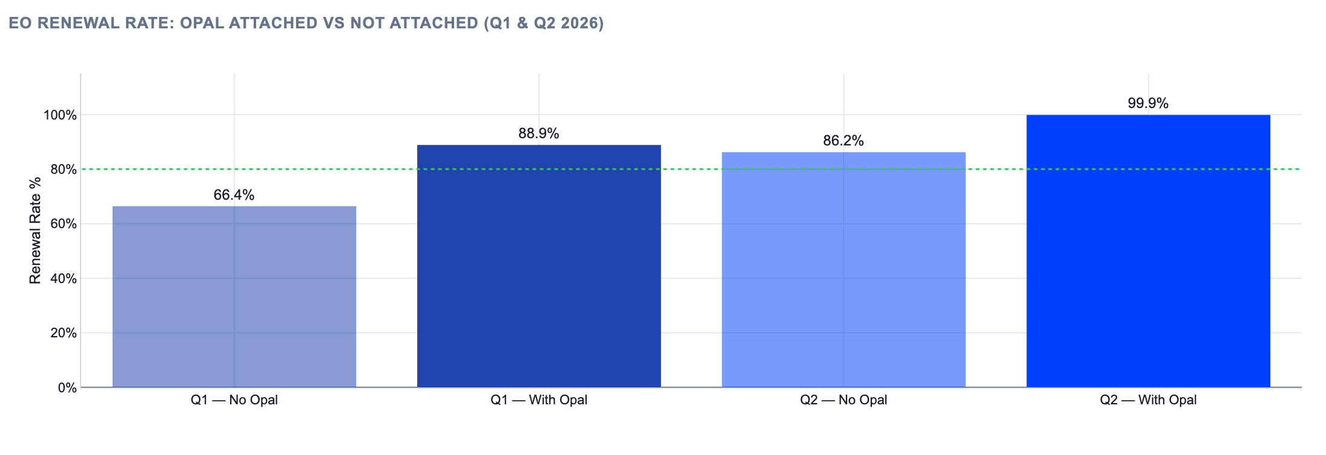
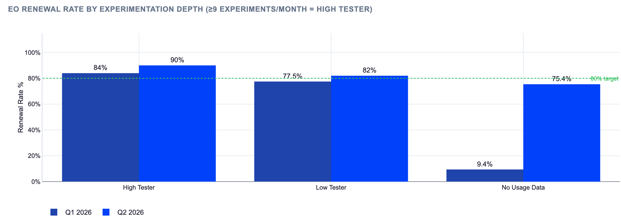
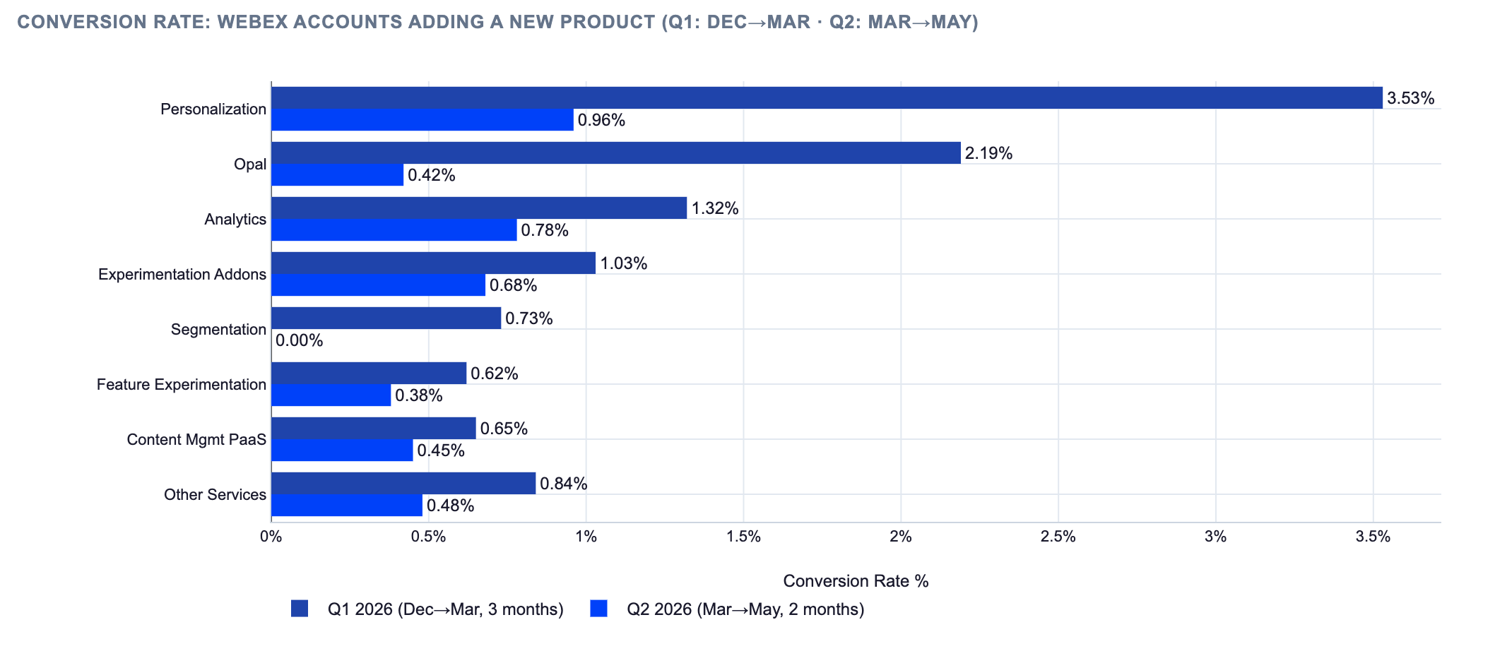
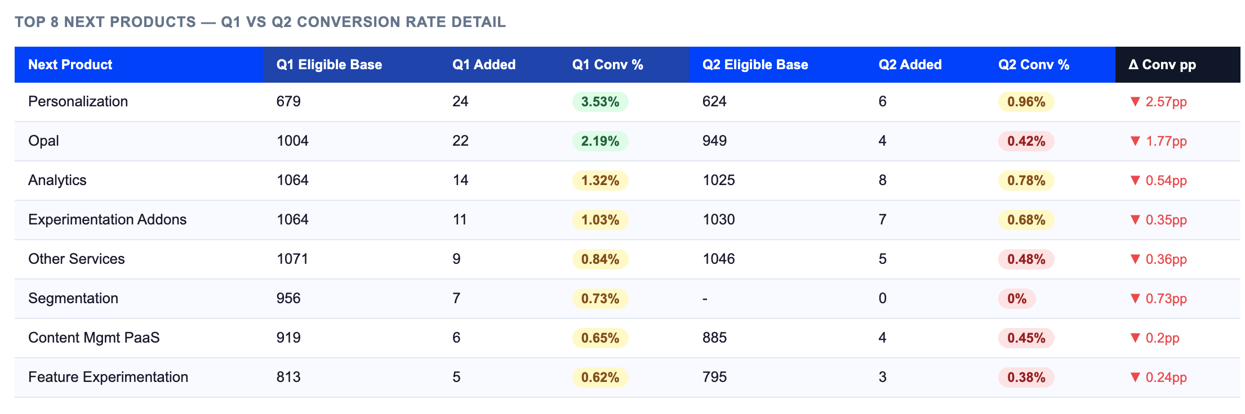
c. Example accounts:
i. top churned this quarter/month:
account name, CSM, region, segment, industry, product solution, product group, renewal arr, churn arr, rr, month/quarter, new churn code
ii. top renewes this quarter/month:
account name, CSM, region, segment, industry, product solution, product group, renewal arr, churn arr, rr, month/quarter, upsell/xsell, new products
d.Product solution deep dives:
i. EO, totals for period and comparison to prior period
list of accounts renewed this quarter/month inlc CSM, region, segment, ARR, Churn, RR, other products?
trend line over time of acc/arr for EO customers
break by region of acc/arr of EO customers
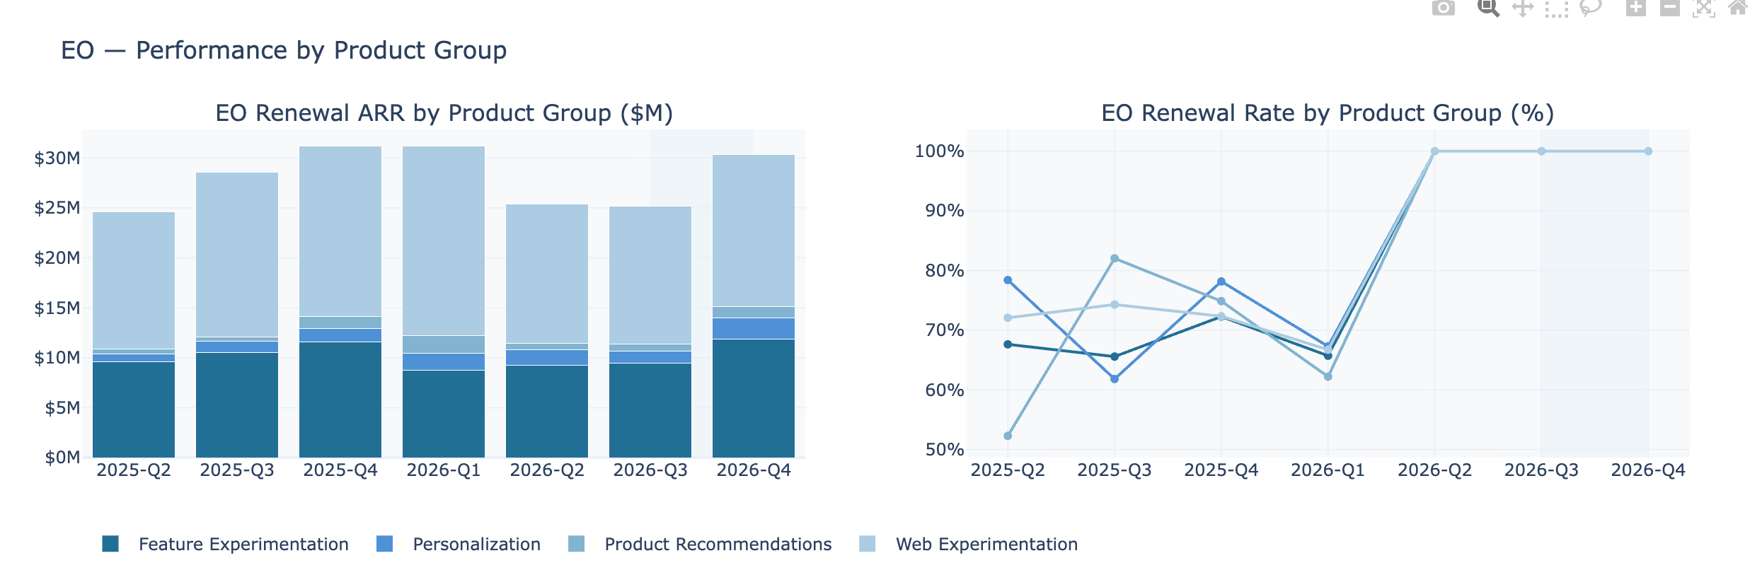
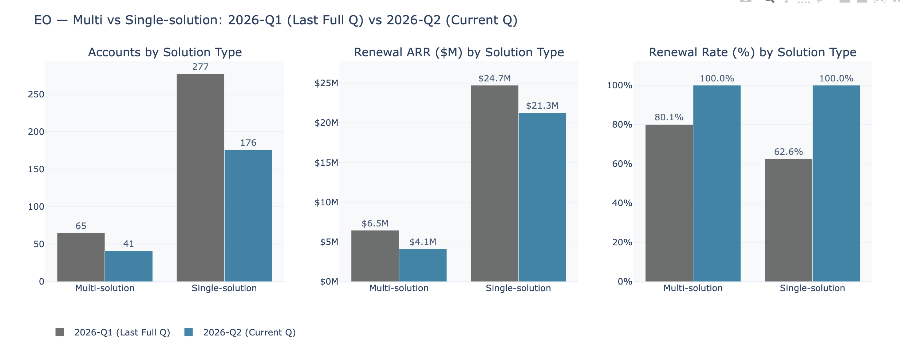
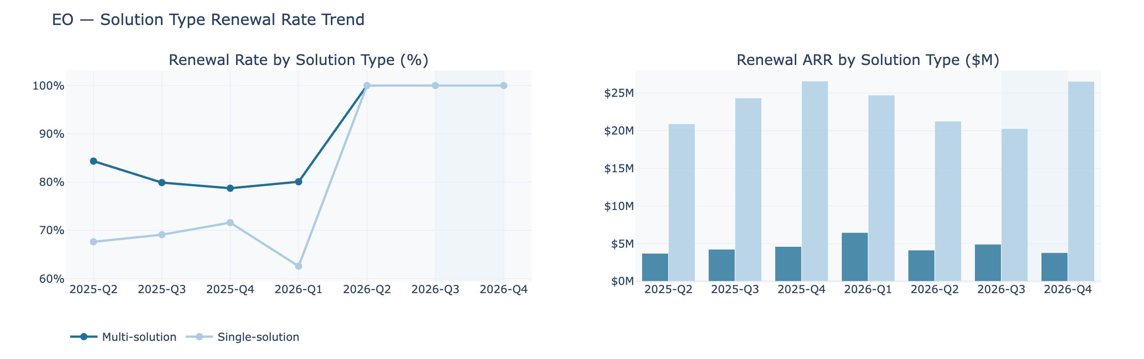

ii. EC, totals for period and comparison to prior period
list of accounts renewed this quarter/month inlc CSM, region, segment, ARR, Churn, RR, other products?
trend line over time of acc/arr for EC customers
break by region of acc/arr for EC customers

iii. Opal: list of current customers: account, region, CSM, ARR, renewal date
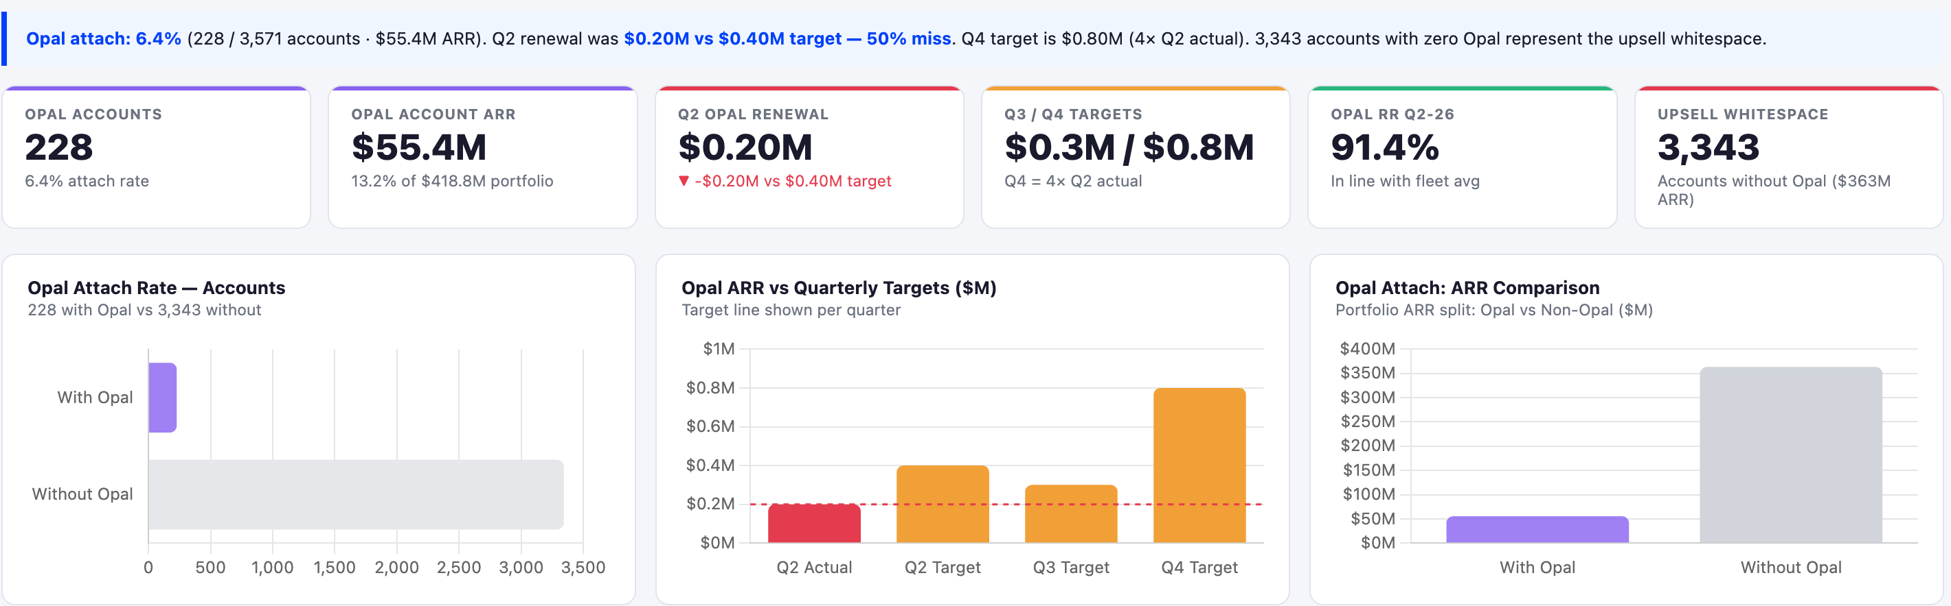
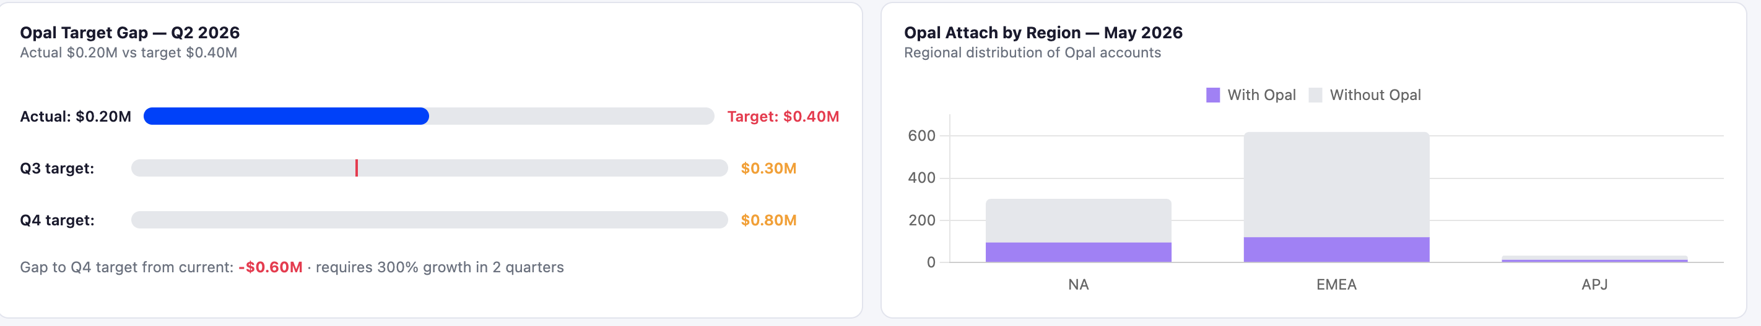
iv. CMS PaaS -> SaaS : table view of top accounts with CMS PaaS coming with renewal in the next quarter. Incl Account name, CMS, region, segment, product groups, ARR, renewal date
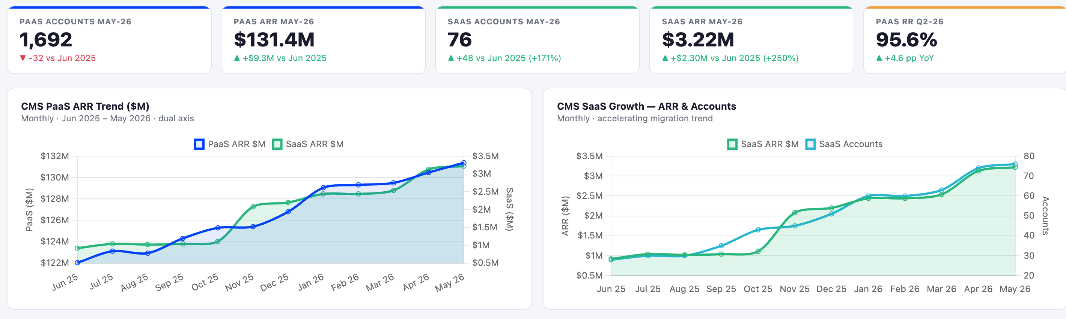
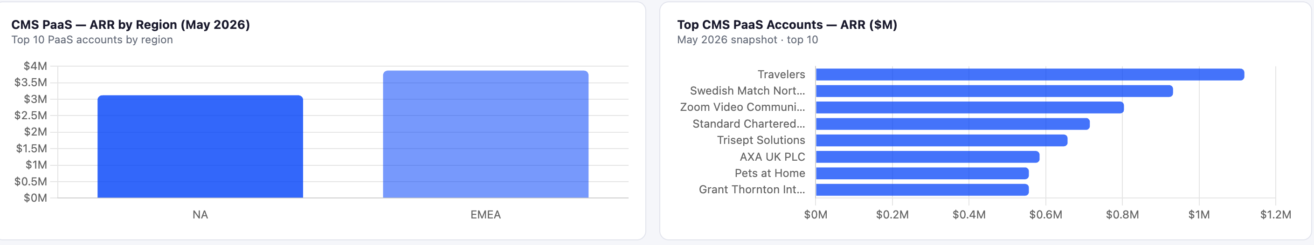

v. OA: score cards arr/acc/rr
trend over time arr/acc/rr
break by region arr/acc/rr
list of current customers: account, region, CSM, ARR, renewal date
vi. cross-sell v upsell analysis
start product > end product flow separate for cross sell and upsell
new products add acc/arr$ and compare regions NAM-EMEA
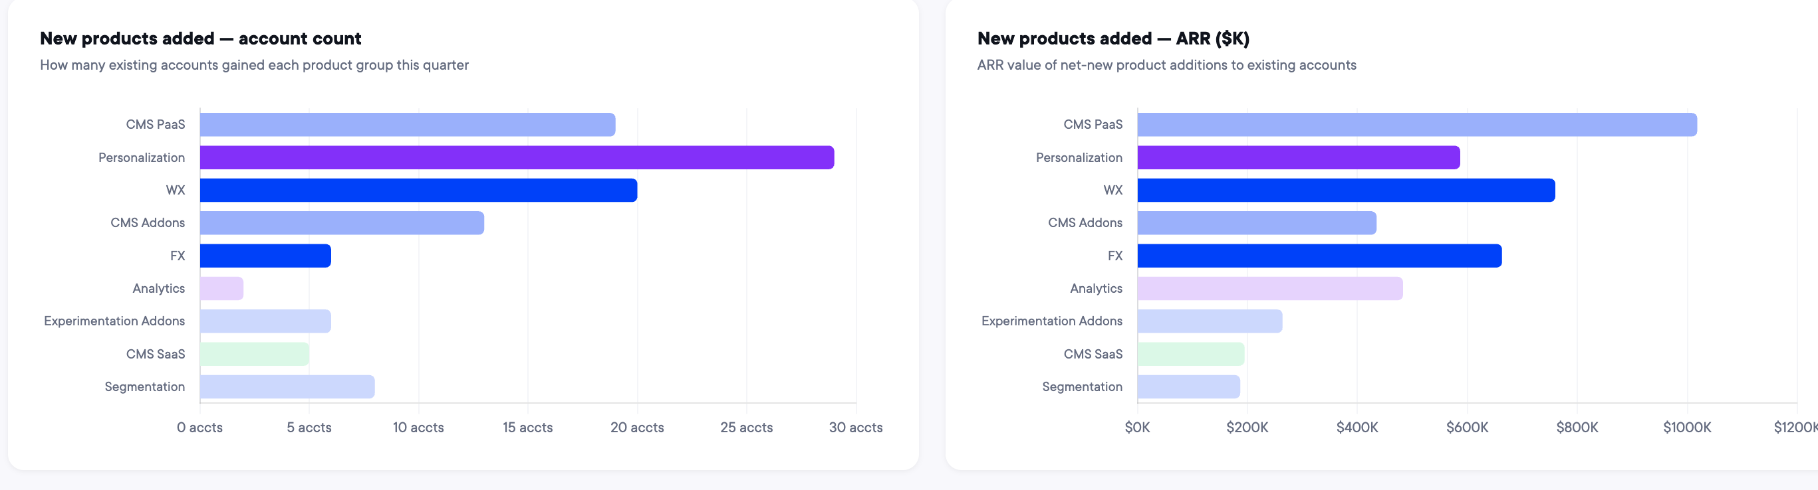
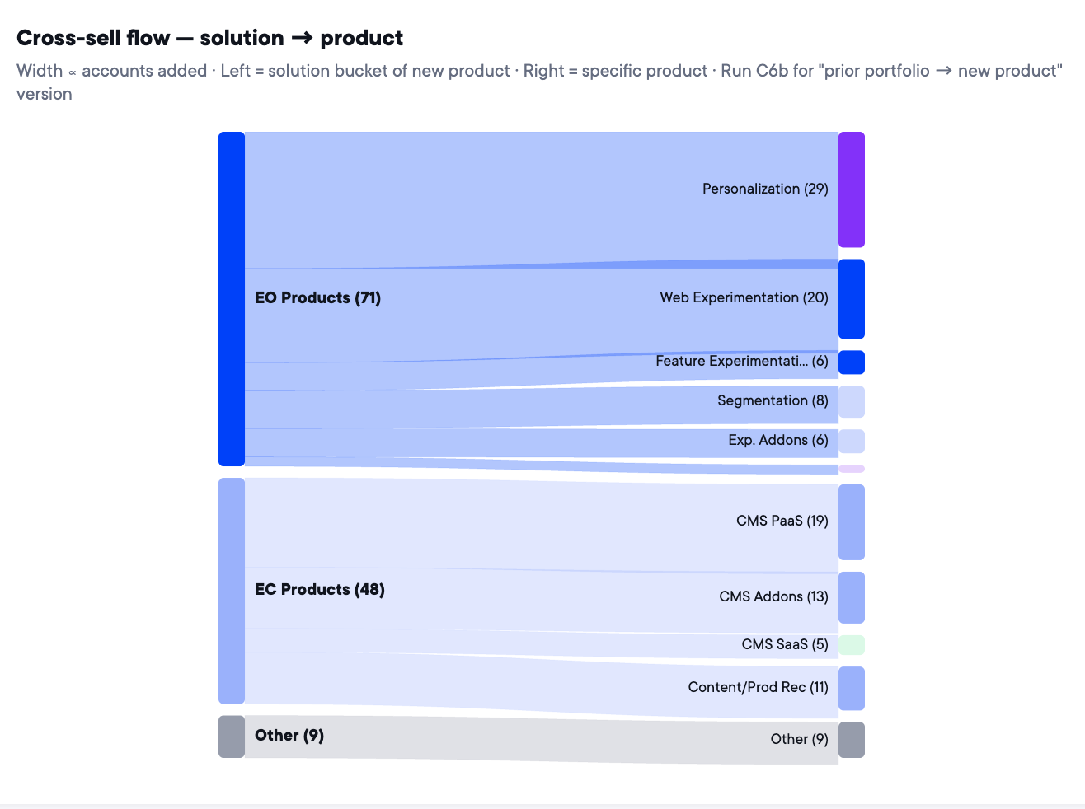
v.

